**DBS Lab 9**

# **Indexes and Views**

1. Create a view call employee_vu based on the employee numbers, employee names and department numbers from the emp table. Change the heading for the ename to EMPLOYEE.
2. Display the contents of the employee_vu view.

Output 1 and 2:

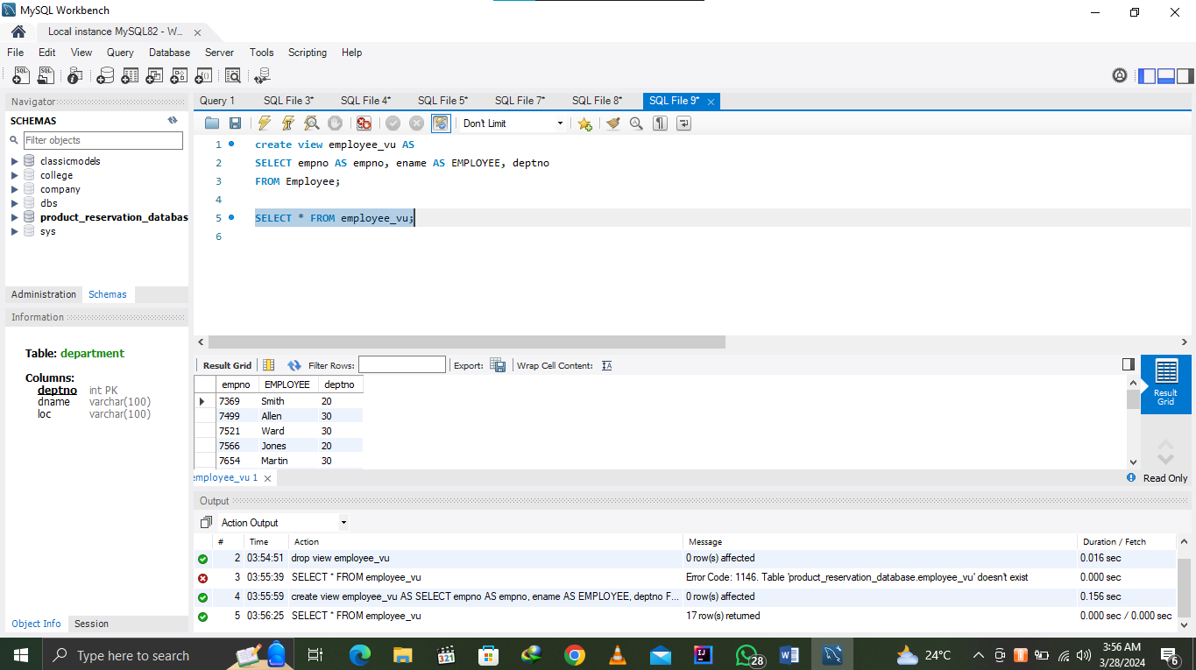

1. Create a view called SALARY_VU based on the employee names, salaries and salary grades for all employees. Use the EMP and SALGRADE tables. Label the columns Employee, salary and grade respectively.

Output: 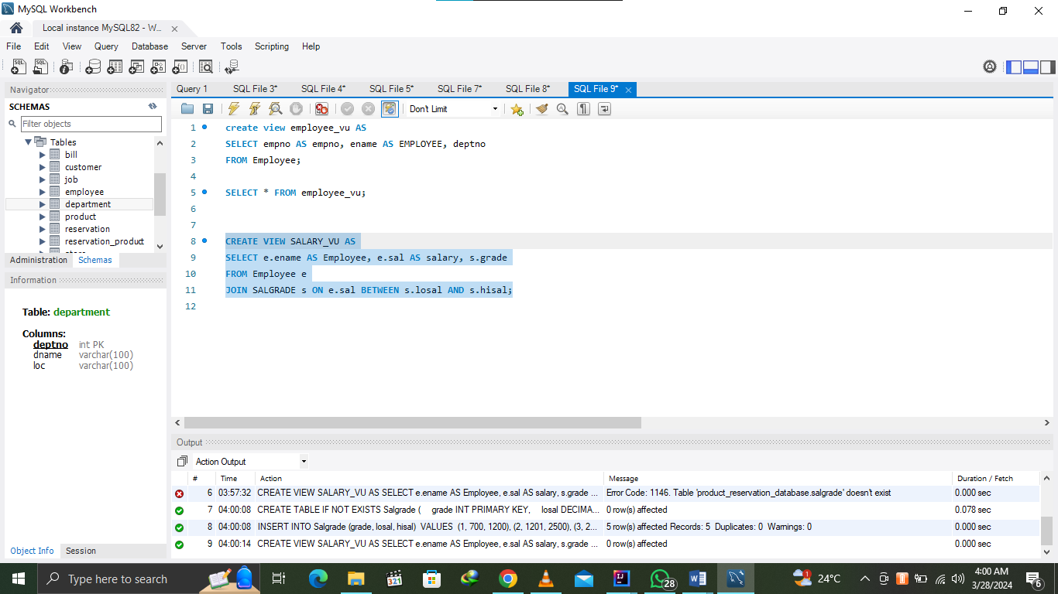

1. Display the structure and contents of the DEPT50 view.

Output: Structure of DEPT50 View 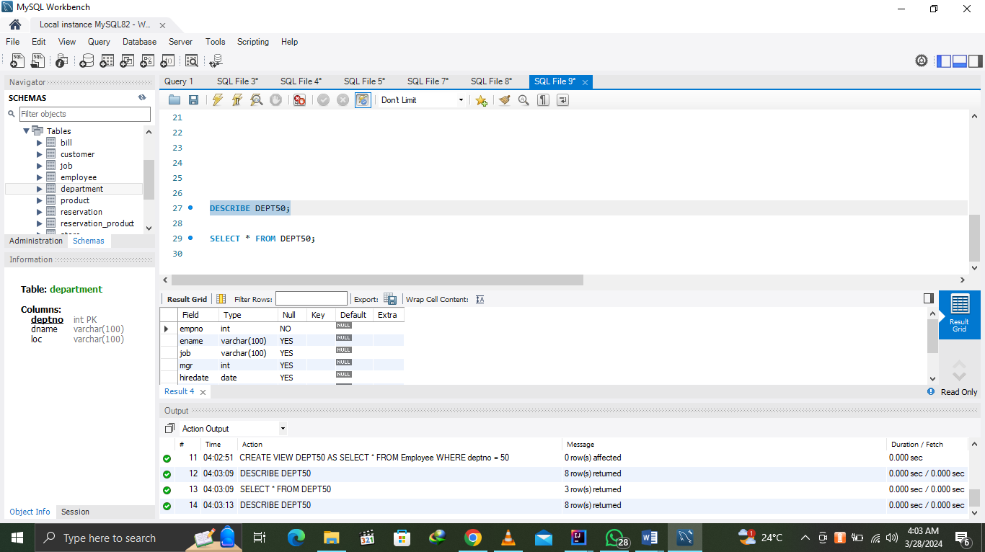

Output: Content of DEPT50 View 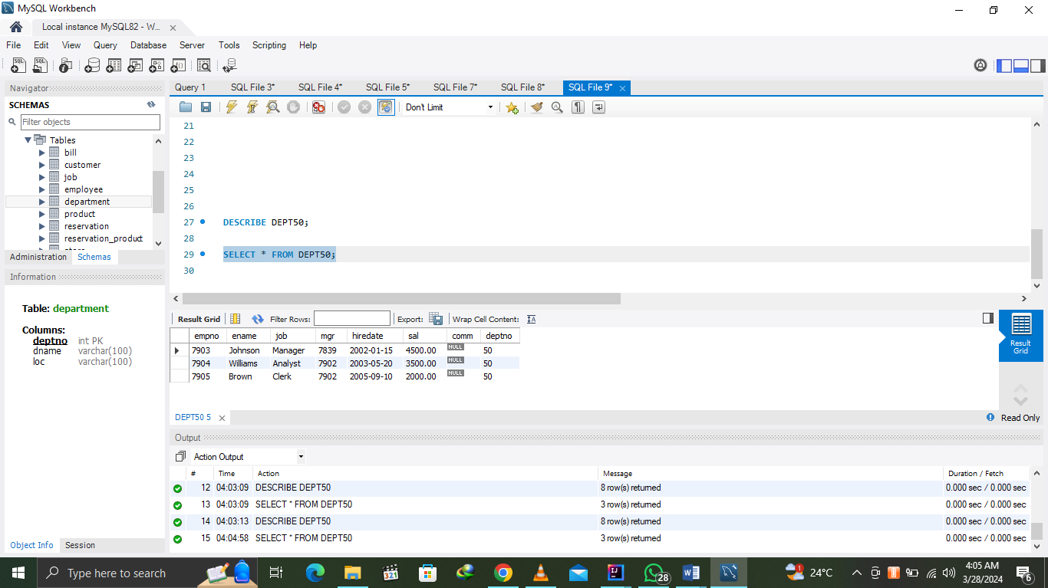

1. Create an index on the deptno of the Emp table. Drop the newly created index.

Output: Create index 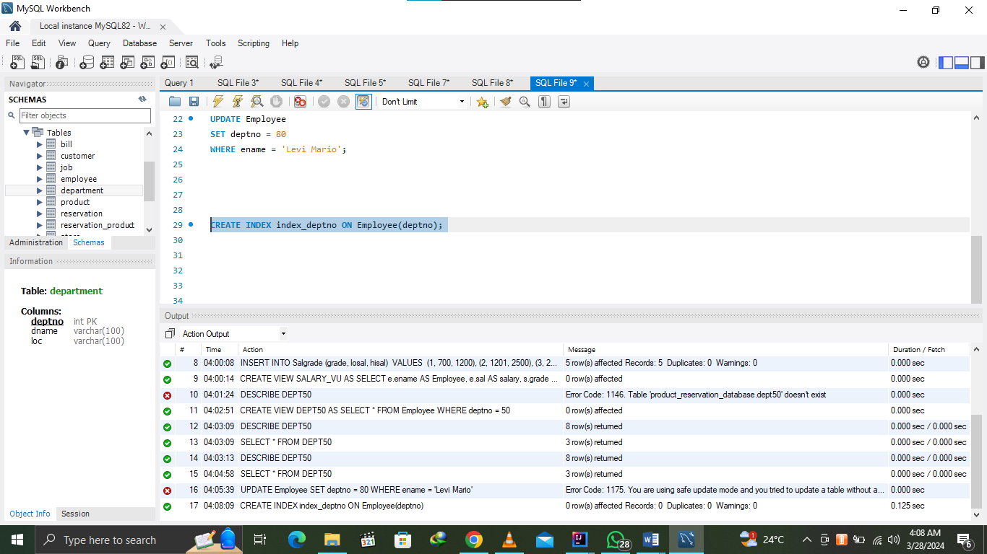

Output: drop index 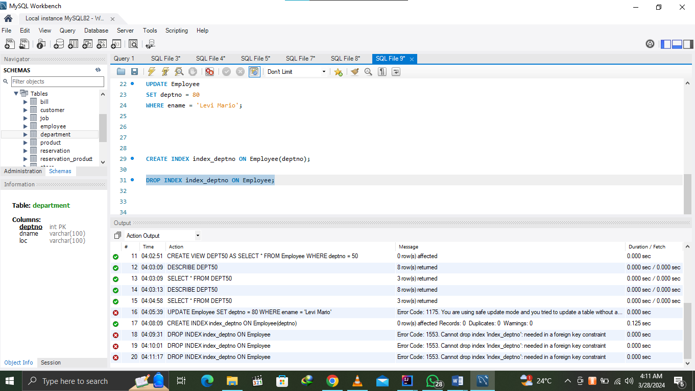

1. Create an index on the job and sal of the Emp table. Drop the newly created index.

Output Create Index: 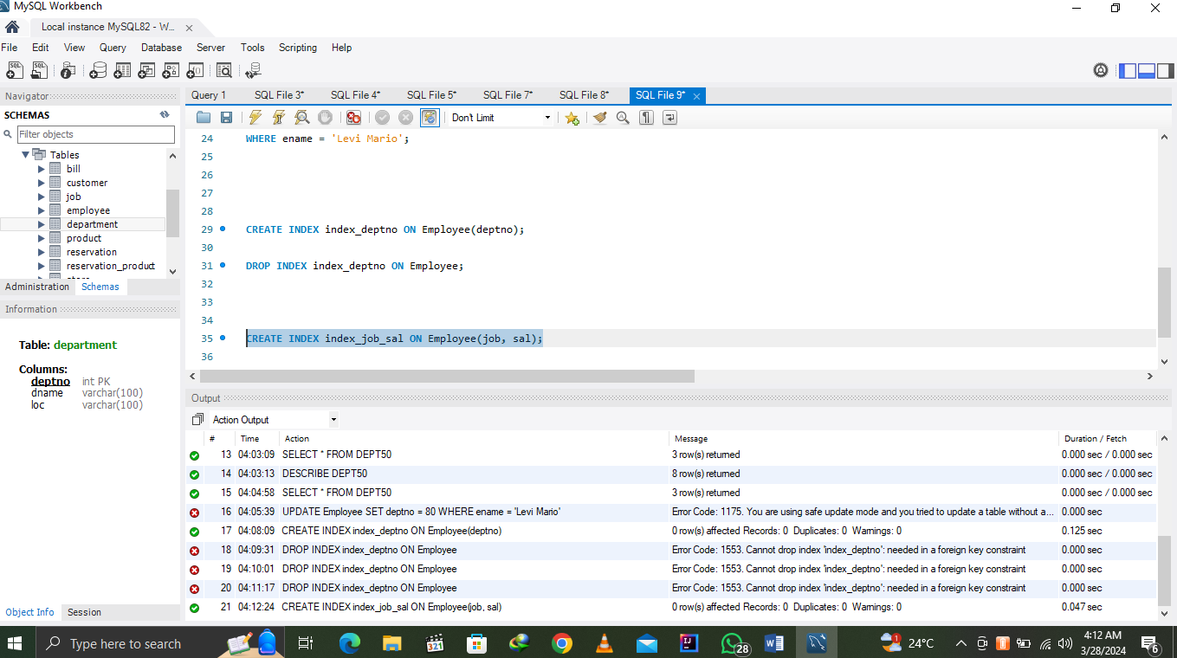

Output Drop Index 